Codigo de prueba de la base robotica ArloBot

Controlador: DHB-10
Arduino uno o mega

¿Cómo es la conexión entre el arduino y el controlador de motores?
SoftwareSerial ArloSerial(12, 13); // RX, TX

DHB-10 -> I/O 12, DHB-10 <- I/O 13

P13 TX servo connector to the DHB-10’s CH1 port
P12 RX servo to the DHB-10’s CH2 port

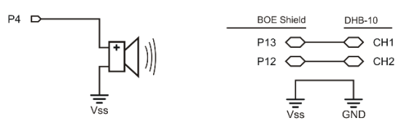

Se coloco el siguiente codigo dentro del loop ya que la primera vez lee 0 y 0:
void loop() {
int fwver = Arlo.readFirmwareVer(); // Check DHB-10 firmware
Serial.print("fwver = "); // Display firmware version
Serial.println(fwver, DEC);

int hwver = Arlo.readHardwareVer(); // Check DHB-10 hardware
Serial.print("hwver = "); // Display hardware version
Serial.println(hwver, DEC);

}

1) Test Arduino to DHB-10 Communication
Programa: Arlo-Test-Arduino-DHB-10-Communication.ino

Salida:
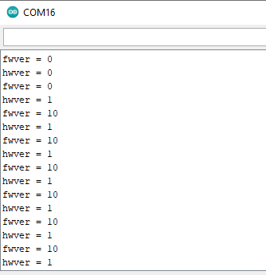

2) Arlo-Test-Motor-Connections
Programa: Arlo-Test-Motor-Connections.ino
OK

3) Test Encoder Connections
Programa: Arlo-Test-Encoder-Connections.ino

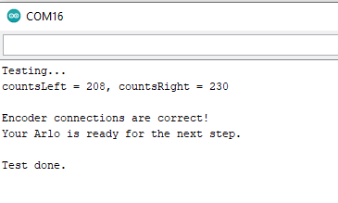

4) Try & Tune Some BOE Shield-Bot Code

Programa: ForwardLeftRightBackward.ino

Funciona como servos

5) Increase BOE Shield Arlo’s Top Speed
Programa:Arlo-Change-Pulse-Scale

Link: https://learn.parallax.com/tutorials/robot/arlo/arlo-arduino-uno-boe-shield-brain/increase-boe-shield-arlo%E2%80%99s-top-speed

Se cambia la escala

6) Control BOE Shield Arlo with the Terminal
Link: https://learn.parallax.com/tutorials/robot/arlo/arlo-arduino-uno-boe-shield-brain/control-boe-shield-arlo-terminal
Programa: Arlo-Terminal-Communication
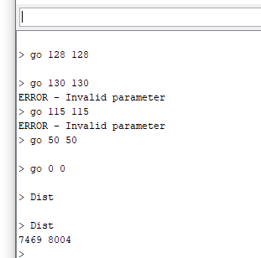

7) More Precise BOE Shield Maneuvers with Encoders

Distance Control

Programa: Arlo-Distance-Maneuvers.ino
Link: https://learn.parallax.com/tutorials/robot/arlo/arlo-arduino-uno-boe-shield-brain/more-precise-boe-shield-maneuvers-encoders

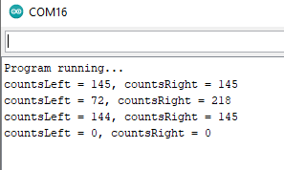

Serial Speed Control
Programa: Arlo-Speed-Maneuvers
Link: https://learn.parallax.com/tutorials/robot/arlo/arlo-arduino-uno-boe-shield-brain/more-precise-boe-shield-maneuvers-encoders

8) Arlo Control System Adjustments

Programa: Arlo-Tune-Integral-Constants
Link: https://learn.parallax.com/tutorials/robot/arlo/arlo-arduino-uno-boe-shield-brain/boe-shield-arlo-control-system-adjustments

